National College of Ireland

Higher Diploma in Science in Computing

Web Design and Client Side Scripting

Lecturer:

Eugene McLaughlin

|  |  |
| --- | --- |
| **STUDENT NAME** | **STUDENT ID** |
| **Esmeralda Cristal Humerez Romero** | **x23150017** |
| **Hyewon Kim** | **x23177250** |
| **Muhammad Syamil Bin Rizaudin** | **x23104660** |
| **Ricardo Abraham Cruz Liga** | **x23127856** |

**“Mofu Mofu Nyan - Website”**

**10/12/2023**

<https://mofu-mofu-nyan.github.io/FINAL-PROJECT/>

|  |  |
| --- | --- |
| **Table of contents:** | **P.2** |
| **1.** Executive summary. | **P. 3** |
| **1.1.** Websites that we consulted: | **P. 3** |
| **2.** Project work. | **P. 4** |
| **3.** Design process. | **P. 4** |
| **3.1.** WIREFRAME – Navbar. | **P. 4** |
| **3.2** WIREFRAME – Landing Page (Home Page). | **P. 5** |
| **3.3** WIREFRAME – Maids. | **P. 6** |
| **3.4** WIREFRAME – Access (Where to Find Us). | **P. 7** |
| **3.5** WIREFRAME – Prices and Packages. | **P. 8** |
| **3.6** WIREFRAME – Reservations. | **P. 9** |
| **3.7** WIREFRAME – Menu. | **P. 10** |
| **3.8** WIREFRAME – Rule Book. | **P. 11** |
| **3.9** WIREFRAME – Minigame. | **P.12** |
| **3.10** HTML, CSS, and Java Script. | **P.13** |
| **4.** Testing and responsiveness. | **P. 16** |
| **4.1.** Responsiveness. | **P. 17** |
| **4.2.** Validation. | **P. 17** |
| **4.3.** Deployment | **P. 29** |
| **Conclusion.** | **P. 33** |
| **References.** | **P. 34** |
| **Links (Website, GitHub, and Video Presentation).** | **P.** |

**1. Executive summary**

Nowadays we have many coffee shops, for that matter we decided to innovate and create a new concept relating a good coffee experience and the Asian culture based on maid cafe.

In addition of that, to give a great service, we have developed a website that can present to the user all the amenities and what type of environment is going to experience with his visit.

Websites are the first contact with clients if they have never been there before, for that reason we need to make it easy and accessible in multiple devices so our site can be reach as much as possible.

The team has agreed into the idea of maid cafe, so we can have different types of pages and we can code with all the knowledge that we had learned during the course.

The first step after choosing a general idea, was to visit some websites that already exist and we can use them as a referent.

**1.1 Websites that we consulted:**

* At-home cafe “ [秋葉原・大阪のメイドカフェなら【あっとほぉーむカフェ】 | 400人のメイドがお出迎え！ (cafe-athome.com)](https://www.cafe-athome.com/)”: The idea of having an Asian coffee shop with drinks, pastries and other things are well represented in this website, making us to use this site as an example to develop the wireframes and to have a general picture of what we wanted to develop.
* Maidreamin “[メイドカフェ・メイド喫茶【めいどりーみん】｜ 秋葉原、大阪、名古屋、小倉、他全世界20店舗展開中! (maidreamin.com)](https://maidreamin.com/multilp/): This website gave us the idea of what type of food and beverage are being served in a maid cafe and how the menu looks like.
* AkihabaraAkiba Absolute ” [Akihabara's Maid Cafe|Akiba Absolute Realm|Kawaii Maid Cafe & Bar (akibazettai.com)](https://akibazettai.com/): With this website we got the principle idea of the page related to maids, how they dress and the costume that makes a maid cafe unique and different from other coffee shops.
* Asayorumaidcafe “[Maid Cafe | Asayoru Maid Cafe](https://www.asayorumaidcafe.com/)”: This website gave us another idea of how a maid cafe website needs to be so we can have an easy interaction with the user.
* Arcanecafe “[A magical maid café in Los Angeles! - Arcane Maid Cafe (arcanecafe.com)](https://arcanecafe.com/)”: Another good example of a maid café is this website, with this we can approach to the main goal that we want to achieve.
* Stable Diffusion “[Stable Diffusion Online (stablediffusionweb.com)](https://stablediffusionweb.com/): This website let us generate photo-realistic images by given any text input.
* Bootstrap “[Bootstrap Icons · Official open source SVG icon library for Bootstrap (getbootstrap.com)](https://icons.getbootstrap.com/)”: Using this tool, we did the fonts and gave a unique style to the website to avoid different pages.

**2. Project work**

After we saw different websites, we agreed to split the pages so everybody will develop two pages and then we can link them.

After we discussed the general idea, and chosen which pages we are going to create, we created the eight wireframes so we can have a main image of how is going to work and the relation between all the pages, so we can have order, and a well-structured website.

**3. Design Process**

**3.1 WIREFRAME – Navbar:**

The navbar is the min tool that links all the pages, we have the Homepage, Information, Maids, Menu, Prices and Packages, Reservations, Minigame and Rule Book. This navbar is very important because it let us interact with the whole website and move to different pages if we need it.

**3.2 WIREFRAME – Landing Page (Home Page):**

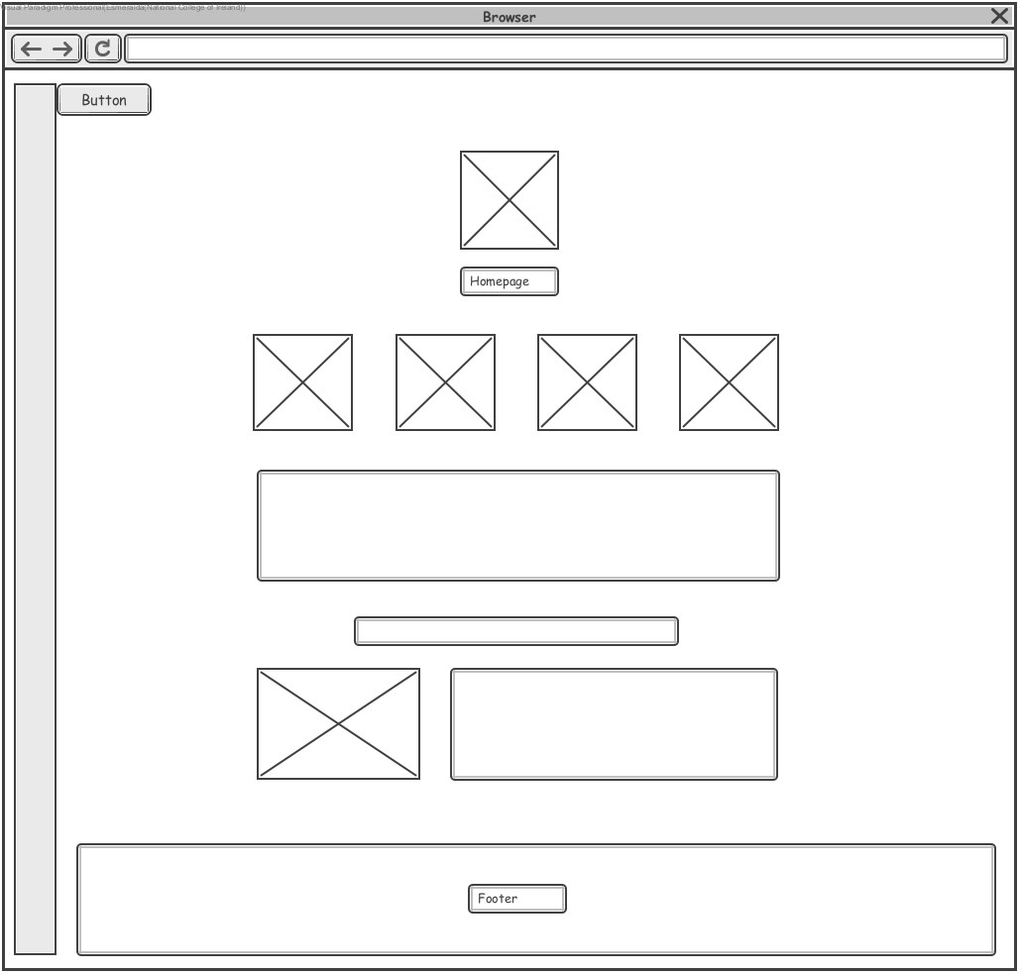

The Homepage was design in order to show to the guests what the business is offering, and focussing on the most important pages like Maids, Menu, Information and Prices.

This page includes the main logo and name of our Website. A small description of what this business offered is also included, and a brief description of all the important parts of this business. Including images, text and emojis.

The pictures and logo were created with AI.

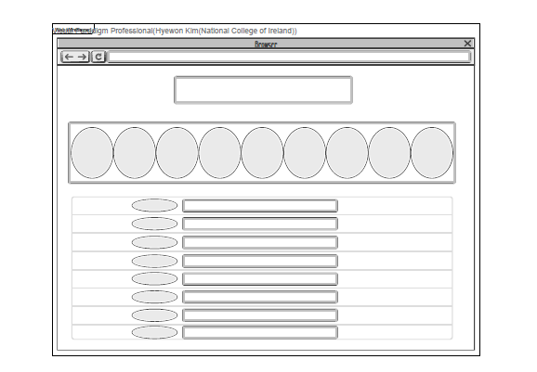**3.3 WIREFRAME – Maids:**

In the maid list, it displays pictures of maids with explanations of their jobs. Using a carousel motion, the pictures come to life on a display stand. It’s set by in an infinite routine, and each of the ten maids has a different job concept, making it more entertaining for customers. It added some emojis next to their names and bios to make it look cuter. The pictures are created using my face with various AI filters. It distinguished the intervals between each maid list box. Additionally, It added a reservation button in the middle of the pages, which is linked and can be used to navigate to the reservation page.

**3.4 WIREFRAME – Access (Where to Find Us):**

The wireframe under review depicts a navbar that links all the pages and the minigame, also we have the opening hours of the coffee shop, then there is an image, under the image there is a chart that represents the days and schedules.

The next part of the image represents the location and a map that will point the exact location, so the user can find the place and interact with the map.

Finally, there is a container that has images of the place to give an idea of how it looks the place.

**3.5 WIREFRAME – Prices and Packages:**

The wireframe in the image shown depicts the ‘Prices & Packages’ page that explains the different fees and packages on offer for customers of our maid café. In the header section, it would display to the user the title of the page *(main header)* that *(not to be confused with the page title in the browser tab)* they are currently on while a sub header below that would display a tagline related to the page.

Below the main header and sub header, the page would then display the different sections of the page which would go into detail for what customers need to expect before coming to the café like making reservations, dress code & etiquette. The other sections would highlight the different fees of the café, staying hours, membership perks, and birthday celebration services. As a nice touch of welcome to potential customers to our café, there is a button within the *‘before coming to the store’* section that when the user clicks on it, would automatically display a video within that section itself.

Lastly, a footer containing our maid café logo, name of our maid café, year, project name, and team name is displayed at the bottom of the page.

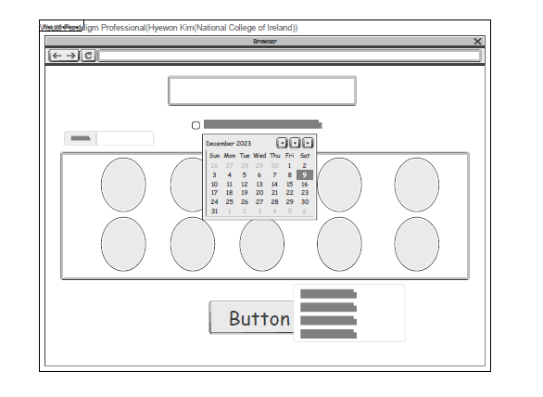**3.6 WIREFRAME – Reservations:**

It has created a reservation page where users can select the desired date and maid name to make a reservation. When a maid is chosen, their name will be displayed in the top-left corner. If the user presses the confirm button without selecting a date, an alert window will prompt them to choose a maid. After selecting the date, time, and maid, pressing the decision button will trigger an alert window to confirm the reservation details. Upon pressing ‘OK’, the page transitions to a window where the user can verify the price.

양식의 맨 위

**3.7 WIREFRAME – Menu:**

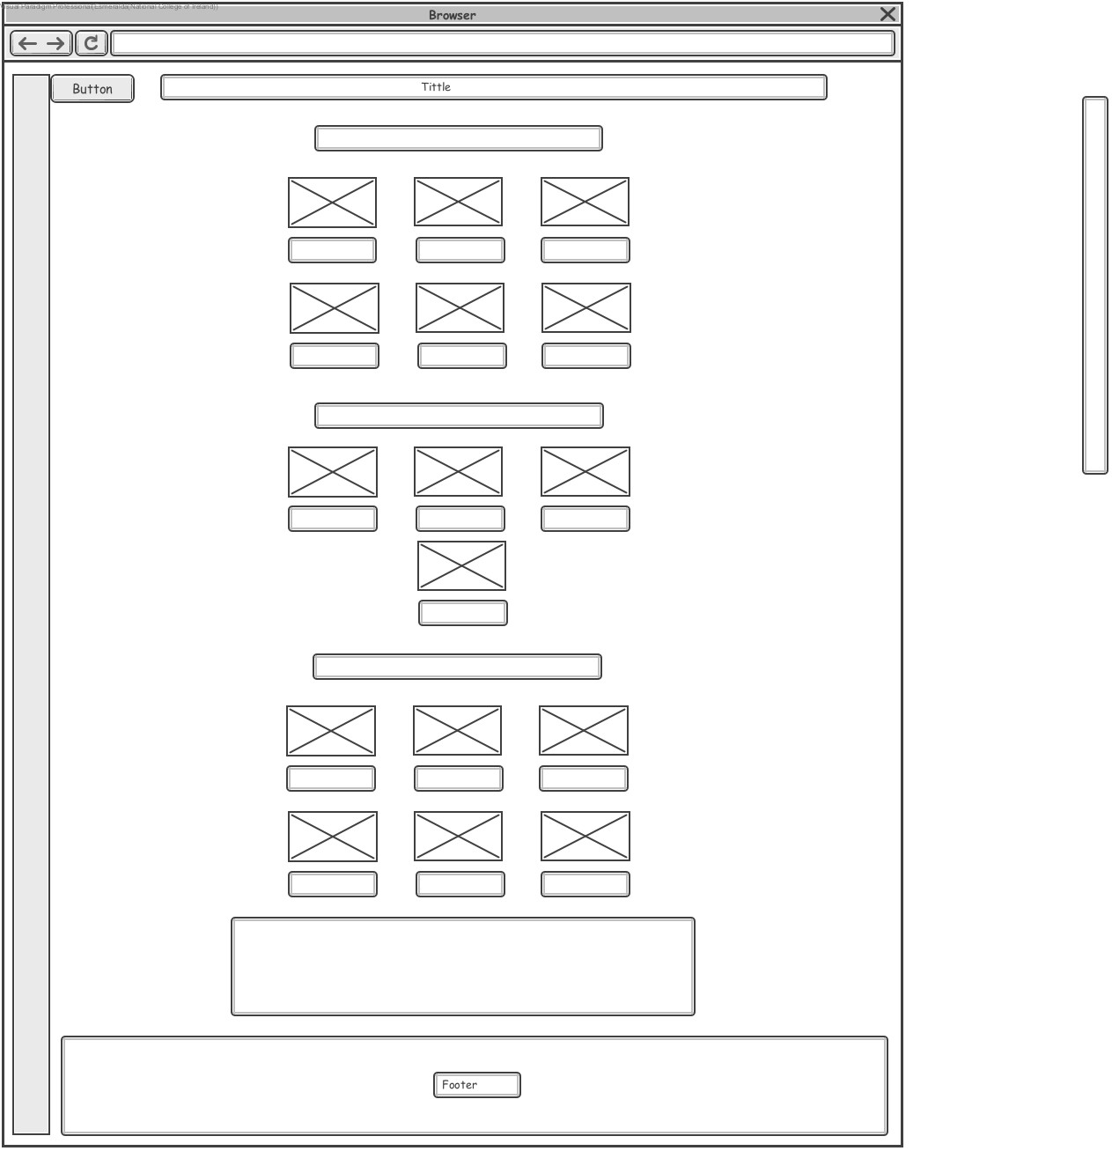

This page includes the menu of the business, it is displayed different options for customers. All the images were generated using AI, that is referenced inside the code. This page also includes a button with a message for the customers, and all the information regarding allergies in food

**3.8 WIREFRAME – Rule Book:**

This wireframe represents the Rule Book. In this page there is a title, secondly there is a list:

* Prohibited.
* Dress appropriately.
* Seating.
* Ordering process.
* Respect other costumers.
* Have Fun.

Finally there is a button created with java script that will display the message “Thanks for accepting the rule book. Enjoy!!!”.

**3.9 WIREFRAME – Minigame:**

The wireframe depicts the page for our *‘Minigame’* where visitors of the page can enjoy playing the classic ‘*Snake’* game. Right at the top of the page, we would have the main header displaying the title and below that, a sub header explaining to the user on the type of game that they would be playing as well as the instructions on how to control the snake within the game.

Below that, the game container containing the actual snake game would be shown. Within the game container of the classic snake game, the score and the current high score would be displayed right above the game field where the users are able to control and see the snake move. At the right corner below the game container, there are two buttons for the users to control the background music as well as the background video that would automatically play in the background of the page.

Finally, we would have the footer containing our maid café logo, name of our maid café, year, project name, and team name is displayed at the bottom of the page.

**3.10 HTML, CSS, and Java Script**

**Esmeralda Cristal Humerez Romero**

The HTML code in order to create two of the webpages for this project, such as the Homepage, Menu Page. These codes were created with containers in order to have the classes organized for the CSS. I have also developed all the code for the navbar, in this case was created as a sidebar, various elements containers, links, buttons and style was implemented.

* HTML: The pages developed were organized inside <div> in order to maintain everything organize and to use the functionalities of flexbox when style the pages. The html files have comments and references for the images created by AI. There was use a <nav> tag to create all the code for the navbar, in order to facilitate the copy of this code to the rest of my team, for their respective pages.
* CSS: All pages include just ONE CSS file, there had been added different parts of each member team. The part I have develop more was the style of the navbar, as there was used classes to make it responsive, there was created the <div class=contain_all> to organize the code of my team.
* Meta Tags: The <meta> tags in the <head> includes the information of each page, and also the information of each team member.
* JavaScript: The is one external JavaScript of each team member, in some cases two or more files are linked to the html code. The script I have developed includes the button menu functionality for the sidebar, it also includes the functionalities for each page showing knowledge of DOM.

**Hyewon Kim**

<HTML>

Creating a basic framework and delineated areas for text and photos. Additionally, to accommodate descriptions of maids, I detailed the sections using Div class codes. With the use of image files and paragraphs, I was able to convey explanations about each maid.

<CSS>

I blended pink and purple colors appropriately for the maid café theme. To maintain a cohesive background, we decided to use the same backdrop as our team members. For the maid photos, I trimmed them and added effects to enhance their visual appeal. Additionally, I incorporated a carousel-like infinite scrolling feature for a dynamic viewing experience. On the reservation page, I added a moving effect to the maid photos, adding an extra layer of fun.

<JavaScript>

I configured the functionality to transition from the Maid List to the Reservation page. On the Reservation page, users can select their desired maid and decide on the date and time. I implemented a ‘Select’ feature to display the maid’s name when chosen. To ensure users select a maid before proceeding, I created an alert prompting them to choose a maid if none is selected. I defined the Reservation function to confirm the selection enabling users to move to the price page after confirmation.

**Muhammad Syamil Bin Rizaudin**

**HTML of *‘PricesAndPackages.html’ page*:**

* **Meta Tags**: These tags provide metadata about the HTML document, such as character set, description, keywords, author, viewport settings, and compatibility.
* **Header Section**: Includes the main title and a sub header for the webpage. It sets the tone and theme for the content.
* **Sections for Prices & Packages**: Each section contains a heading (**<h2>**), introductory paragraph (**<p>**), and an unordered list (**<ul>**) with list items (**<li>**) providing detailed information.
* **YouTube Video Embed**: A button (**<button>**) labeled *"Welcome Home, Master & Princess!"* that triggers the **playVideo()** JavaScript function. The actual video is embedded inside a container (**<div>**)
* **Scripts**: Script tags at the end of the body to include my JavaScript file (**script.js**). Also embedded is a video (**syamuVideo**) with autoplay, loop, and muted attributes.

**HTML of *‘SnakeMinigame.html’ page*:**

* **Meta Tags**: Like the *‘PricesAndPackages.html’* page, it provides the metadata about the HTML document.
* **Header Section**: Includes the main title and a sub header of the Snake Game page.
* **Snake Game Container**: A container (<div class="wrapper">) for the Snake game, including a scoreboard, controls, and the game board.
* **Embedded Video and Audio**: An embedded video (syamuVideo) with autoplay, loop, and muted attributes. There's also background music and sound effects for the game.
* **Footer**: A footer with buttons to play/pause the background video and play/pause the background music.

**CSS:**

* **Global Styles**: The * selector is used for global styles, setting margin, padding, and box-sizing to create a consistent layout.
* **Header Styles**: Styling for the header and sub header, including font families, colours, and spacing.
* **Container Styles**: Styling for the container holding Prices & Packages content. It includes background colour, padding, and border.
* **Font Styles**: Imported Google Fonts and applied them to various elements for a consistent and visually appealing look.
* **Video and Button Styles**: Styles for video backgrounds, control buttons, and the Snake game container.

**JavaScript:**

* **Video and Music Control Functions**: Functions toggleVideo() and toggleMusic() toggle the play/pause state of the background video and music.
* **Snake Game Logic**: The Snake game logic, including handling key events, updating the game board, checking for collisions, and updating the score. The Snake game is based on the code from CodingNepal.
* **YouTube Video Function**: The playVideo() function embeds a YouTube video when called.

**Ricardo Abraham Cruz Liga**

The HTML code is designed to create a webpage that provides information about the location and opening hours of "Mofu-Mofu-Nyan." The code includes various elements such as headings, images, tables, a map, a container with pictures and a rulebook with a button that displays a message by using an external java script.

* HTML Structure: The code follows the standard HTML structure, starting with the <!DOCTYPE html> declaration and containing the <html>, <head>, and <body> tags.
* CSS Styling: The code includes a link to an external CSS file to apply styles to the webpage. The CSS file contains rules that define the appearance of elements such as headings, images, navbar, style, size, font, and position.
* Meta Tags: The <meta> tags in the <head> section provide additional information about the webpage. These tags include the page title, description, keywords, author, viewport settings, and compatibility with Internet Explorer.
* Content: The code includes various elements to display such as headings, images, a table, a map, and a video background.
* JavaScript: The code includes a reference to an external JavaScript, this file add interactivity and functionality to the webpage like create a container where the picture slides are changing automatically every two seconds and displaying an alert when the user press the button.

**4. Testing and responsiveness.**

**4.1 Responsiveness**

The containers grill examples from bootstrap were used on the page, in order to make them responsive, depending on the size of the display. We also have included some icons from this page, inserting the corresponding script and style from it.

**4.2 Validation**

For the validation we did a satisfactory pre-deployment, the only thing is that we fixed some errors that can give a better quality to the website.

For this part, we have used the web site W3C Markup Validation Service <https://validator.w3.org/>.

In this site we validated the HTML and the CSS.

* Index:

* Maid list:

* Menu:A screenshot of a computer

  Description automatically generatedA screenshot of a computer

  Description automatically generatedA screenshot of a computer

  Description automatically generated

* Prices and packages:A screenshot of a computer

  Description automatically generatedA screenshot of a computer

  Description automatically generatedA screenshot of a computer

  Description automatically generated

* Reservation: A screenshot of a computer

  Description automatically generatedA screenshot of a computer

  Description automatically generated

* Rule Book:

* Snake Minigame:A screenshot of a computer

  Description automatically generatedA screenshot of a computer

  Description automatically generated

* Where to find us:

**4.3 Deployment**

We have created a successful deployment, for that reason we have a link that can be open and display the pages that we have developed.

The final link is <https://mofu-mofu-nyan.github.io/FINAL-PROJECT/>.

**Conclusion**

The result depicts a good website that is easy to navigate when you are interacting as a user and as a developer. The navbar works perfectly and all the links are working right.

In addition of that, all the pages have important information and the code that shows a good HTML, CSS and java script.

We have developed a website that satisfies all the points that we had decided in the beginning, it most be a good website that represents the good team work that we have been doing during this days.

The most important part is that all the knowledge of the course is well represented in this project.

To sum up, this website is going to be a referent for future generations that want to develop a website.

**References**

(2021a). YouTube. 2 June. Available at: https://www.youtube.com/watch?v=6MByi5l7OiM&ab_channel=LucasVeuve (Accessed: 09 December 2023).

(2021b) *Pixabay.com - Sound Effects : Game Over Arcade* [Preprint]. Available at: https://pixabay.com/sound-effects/game-over-arcade-6435/ (Accessed: 09 December 2023).

(2022) *Pixabay.com - Sound Effects : Eating Sound Effect* [Preprint]. Available at: https://pixabay.com/sound-effects/eating-sound-effect-36186/ (Accessed: 09 December 2023).

(2023) *Pixabay.com - Video games 8 bit arcade* [Preprint]. Pixabay. Available at: https://pixabay.com/music/video-games-8-bit-arcade-138828/ (Accessed: 09 December 2023).

CodingNepal, By and CodingNepal (2023) *How to create a snake game in HTML CSS & JavaScript*, *CodingNepal*. Available at: https://www.codingnepalweb.com/create-snake-game-htm-css-javascript/ (Accessed: 09 December 2023).

Gamulinskii, O. (2021) *An Animated Video of Landscape Free Stock Video Footage, Royalty-Free 4K & HD Video Clip*. Pexels. Available at: https://www.pexels.com/video/an-animated-video-of-landscape-8879031/ (Accessed: 09 December 2023).

null, motionstock (2019) *Pixabay.com - Videos : Love Love Birds Hearts Valentines*. Available at: https://pixabay.com/videos/love-love-birds-hearts-valentines-26066/ (Accessed: 09 December 2023).

**Links (Website, GitHub, and Video Presentation).**

**Website:** https://mofu-mofu-nyan.github.io/FINAL-PROJECT/

**GitHub:** https://mofu-mofu-nyan.github.io/FINAL-PROJECT/

**Video presentation:**

https://studentncirl-my.sharepoint.com/:v:/g/personal/x23104660_student_ncirl_ie/EVcQ7EBYQpdEvduGGOPhkucBbTXzHOrAwADH8y9WpgXhEg?nav=eyJyZWZlcnJhbEluZm8iOnsicmVmZXJyYWxBcHAiOiJPbmVEcml2ZUZvckJ1c2luZXNzIiwicmVmZXJyYWxBcHBQbGF0Zm9ybSI6IldlYiIsInJlZmVycmFsTW9kZSI6InZpZXciLCJyZWZlcnJhbFZpZXciOiJNeUZpbGVzTGlua0NvcHkifX0&e=wRT8Ui